**Tool & Technique Laboratory (T&T Lab.)**

**[CS-3096]**

**Individual Work**

**Lab. No:1 , Date: 17-01-2023 , Day:TUESDAY**

**Topic:**

| **Roll Number:** | **20051939** | **Branch/Section:** | **cse/17** |
| --- | --- | --- | --- |
| **Name in Capital:** | **SHASHIKANT SHAH** | | |

**(Instruction:** Rename this file as r-LAB-x where r is your roll number & x is your lab. number & Suppose your roll number is 1905123 & you want to submit lab-2 programs, then file name should be 1905123-LAB-2. Finally delete all texts inside parentheses, also parenthesis)

**Program No: (**1.1)

**Program Title:**

(Write here your program title in detail)

1. WAP to subtract a number from another number and display the result.

**Input/Output Screenshots:**

**RUN-1:**

(Paste here the screenshots of first run)

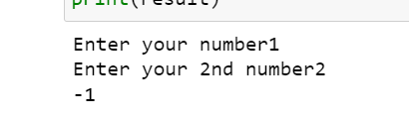

**RUN-2**

(Paste here the screenshots of second run )

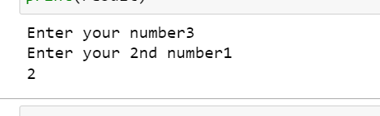

**Source code**

(Paste here the source code)

#WAP to subtract a number from another number and display the result.

a=int(input('Enter your number'))

b=int (input('Enter your 2nd number'))

result =a-b ;

print(result)

**Conclusion/Observation**

Successfully subtract a number from another number

—---------------------------------------------------------------------------------------------------------------------------

**Program No: (**1.2)

**Program Title:**

(Write here your program title in detail)

2 WAP to convert temperature from centigrade to Fahrenheit scale.

**Input/Output Screenshots:**

**RUN-1:**

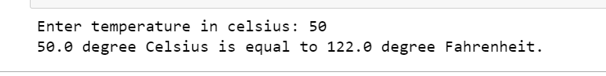

**Input/Output Screenshots:**

**RUN-2**

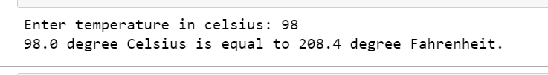

**Source code**

(Paste here the source code)

celsius = float(input("Enter temperature in celsius: "))

fahrenheit = (celsius * 1.8) + 32

print(str(celsius )+ " degree Celsius is equal to " + str(fahrenheit )+ " degree Fahrenheit.")

**Conclusion/Observation**

Successfully convert temperature from centigrade to Fahrenheit scale

— — — — — — — — — — — — — — — — — — — — — — — — — — — — — — — — —

**Program No: (**1.3)

3.)WAP to calculate perimeter of a circle.

Run 1 :

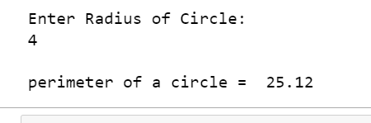

Run 2 :

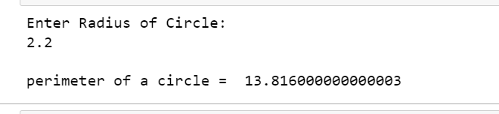

**Source code :**

print("Enter Radius of Circle: ")

r = float(input())

pie = 3.14

c = 2 * pie * r

print("\nperimeter of a circle = ", c)

**Conclusion/Observation**

Successfully calculate perimeter of a circle

—-------------------------------------------------------------------------------------------------------------------

**Program No: (**1.4)

**Program Title:**

(Write here your program title in detail)

4. WAP to calculate area of a triangle whose three sides are given.

**Input/Output Screenshots:**

**RUN 1**

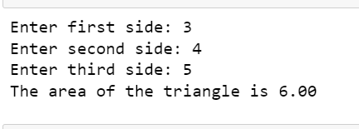

**RUN 2**

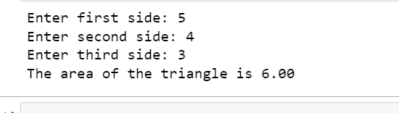

**Source code :**

# Three sides of the triangle is a, b and c:

a = float(input('Enter first side: '))

b = float(input('Enter second side: '))

c = float(input('Enter third side: '))

# calculate the semi-perimeter

s = (a + b + c) / 2

# calculate the area

area = (s*(s-a)*(s-b)*(s-c)) ** 0.5

print('The area of the triangle is %0.2f' %area)

**Conclusion/Observation**

Successfully calculate area of a triangle whose three sides are given

—---------------------------------------------------------------------------------------------------------------------------

**Program No: (**1.5)

5.)WAP to swap two integer numbers without using third variable.

**Input/Output Screenshots:**

**RUN 1**

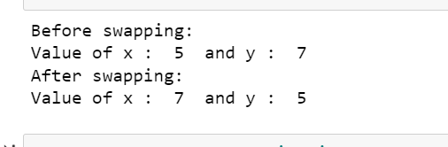

**RUN 2**

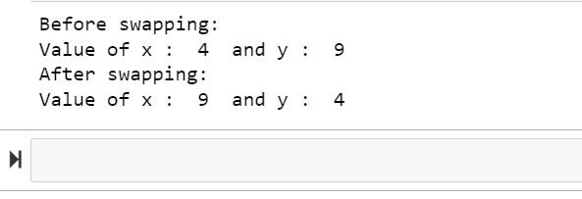

**Source code :**

**#5 #WAP to swap two integer numbers without using third variablee**

x = 4

y = 9

print ("Before swapping: ")

print("Value of x : ", x, " and y : ", y)

# code to swap 'x' and 'y'

x, y = y, x

print ("After swapping: ")

print("Value of x : ", x, " and y : ", y)

**Conclusion/Observation**

Successfully swap two integer numbers without using third variablee

—--------------------------------------------------------------------------------------------------------------------------

**Program No: (**1.6)

6.)WAP to convert a quantity in meter entered through keyboard into its equivalent kilometer andmeteras per the following format. Example. 2430 meter = 2 Km and 430 meter

**Input/Output Screenshots:**

**RUN 1**

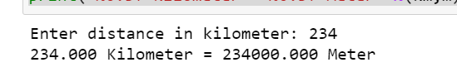

**RUN 2**

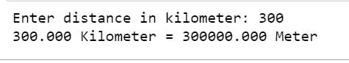

**Souce code**

# 6 python program to convert km to m

# Reading input

km = input("Enter distance in kilometer: ")

# Converting to float data type

km = float(km)

# Converting to meter

m = km * 1000;

print("%0.3f Kilometer = %0.3f Meter" %(km,m))

**Conclusion/Observation**

Successfully WAP to convert a quantity in meter entered through keyboard into its equivalent kilometer and meteras

—---------------------------------------------------------------------------------------------------------------------------

**Program No: (**1.7)

**Program Title:**

WAP to find the average mark of 5 subjects of a student and find the percentage. Assumefull markofeach subject is 100.

**Input/Output Screenshots:**

**RUN 1**

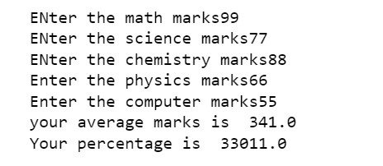

**Run 2**

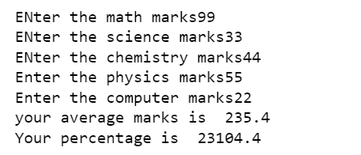

**Souce code**

m= float(input("ENter the math marks"))

s= float(input("ENter the science marks"))

c= float(input("ENter the chemistry marks"))

p = float(input("Enter the physics marks"))

com= float(input("Enter the computer marks"))

Average = float(m+s+c+p+com/5 )

percentage = float((m+s+c+p+com/500)*100)

print("your average marks is ",Average)

print("Your percentage is ",percentage)

**Conclusion/Observation**

Successfully average mark of 5 subjects of a student and find the percentage. Assumefull markofeach subject is 100.

—---------------------------------------------------------------------------------------------------------------------------

**Program No: (**1.8)

**Program Title:**

WAP swap the contents of two variables by using a single statement for swap in C.

**Input/Output Screenshots:**

**RUN 1**



**RUN 2**



**Source code**

x = 22

y = 555

x, y = y, x

print("After Swapping values of x and y are", x, y)

**Conclusion/Observation**

Successfully swap the contents of two variables by using a single statement

—-------------------------------------------------------------------------------------------------------------------

**Program No: (**1.9)

**Program Title:**

**9.)** WAP to add two times in hour, minitue & second format entered through the keyboardintheformathh:mm:ss

**Input/Output Screenshots:**

**RUN 1**

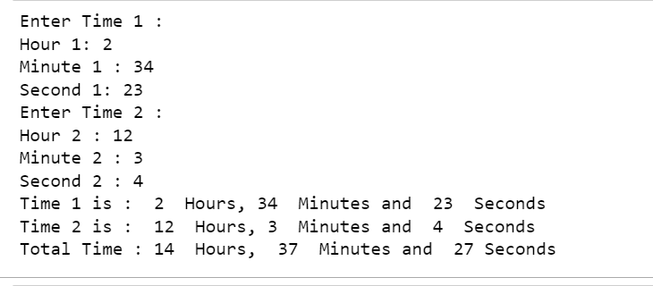

**RUN 2**

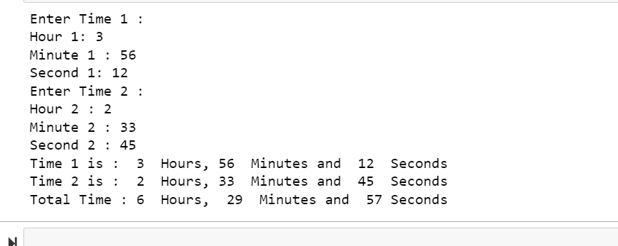

**Source code**

print("Enter Time 1 :")

h1=int(input("Hour 1: "))

m1=int(input("Minute 1 : "))

s1=int(input("Second 1: "))

print("Enter Time 2 :")

h2=int(input("Hour 2 : "))

m2=int(input("Minute 2 : "))

s2=int(input("Second 2 : "))

h3=h1+h2+(m1+m2+(s1+s2)//60)//60

m3=(m1+m2+(s1+s2)//60)%60

s3=(s1+s2)%60

print("Time 1 is : ",h1," Hours,",m1," Minutes and ",s1," Seconds")

print("Time 2 is : ",h2," Hours,",m2," Minutes and ",s2," Seconds")

print("Total Time :",h3," Hours, ",m3," Minutes and ",s3,"Seconds")

**Conclusion/Observation**

Successfully add two times in hour, minitue & second format entered through the keyboardintheformathh:mm:ss

**Program No: (**1.10)

**Program Title:** WAP to input any two integers distinct and display the greater of two integers

**Input/Output Screenshots:**

**RUN 1**



**RUN 2**



**Source code**

**def maximum(a, b):**

**if a >= b:**

**return a**

**else:**

**return b**

**# Driver code**

**a = 2**

**b = 6**

**print(maximum(a, b))**

**Conclusion/Observation**

Successfully input any two integers distinct and display the greater of two integers

—-----------------------------------------------------------------------------------------------------------------

**Program No: (**1.11)

**Program Title:** WAP to input any three integers distinct and display the greater of three integers

**Input/Output Screenshots:**

**RUN 1**

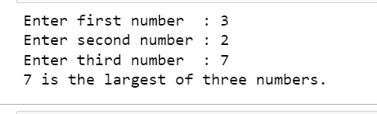

**RUN 2**

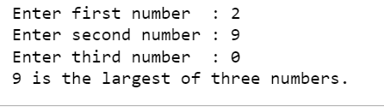

**Source code**

**a = int(input('Enter first number : '))**

**b = int(input('Enter second number : '))**

**c = int(input('Enter third number : '))**

**largest = 0**

**if a > b and a > c :**

**largest = a**

**elif b > c :**

**largest = b**

**else :**

**largest = c**

**print(largest, "is the largest of three numbers.")**

**Conclusion/Observation**

Successfully compile any three integers distinct and display the greater of three integers

—---------------------------------------------------------------------------------------------------------------------------

**Program No: (**1.12)

**Program Title:**WAP to test whether a number entered through keyboard is ODD or EVEN

**Input/Output Screenshots:**

**RUN 1**